Git Checkout

This page is an examination of the git checkout command. It will cover usage examples and edge cases. In Git terms, a "checkout" is the act of switching between different versions of a target entity. The git checkout command operates upon three distinct entities: files, commits, and branches. In addition to the definition of "checkout" the phrase "checking out" is commonly used to imply the act of executing the git checkout command. In the Undoing Changes topic, we saw how git checkout can be used to view old commits. The focus for the majority of this document will be checkout operations on branches.
Checking out branches is similar to checking out old commits and files in that the working directory is updated to match the selected branch/revision; however, new changes are saved in the project history—that is, it’s not a read-only operation.

Checking out branches
The git checkout command lets you navigate between the branches created by git branch. Checking out a branch updates the files in the working directory to match the version stored in that branch, and it tells Git to record all new commits on that branch. Think of it as a way to select which line of development you’re working on.
Having a dedicated branch for each new feature is a dramatic shift from a traditional SVN workflow. It makes it ridiculously easy to try new experiments without the fear of destroying existing functionality, and it makes it possible to work on many unrelated features at the same time. In addition, branches also facilitate several collaborative workflows.
The git checkout command may occasionally be confused with git clone. The difference between the two commands is that clone works to fetch code from a remote repository, alternatively checkout works to switch between versions of code already on the local system.

Usage: Existing branches
Assuming the repo you're working in contains pre-existing branches, you can switch between these branches using git checkout. To find out what branches are available and what the current branch name is, execute git branch.
$> git branch
master
another_branch
feature_inprogress_branch
$> git checkout feature_inprogress_branch
The above example demonstrates how to view a list of available branches by executing the git branch command, and switch to a specified branch, in this case, the feature_inprogress_branch.

New Branches
Git checkout works hand-in-hand with git branch. The git branch command can be used to create a new branch. When you want to start a new feature, you create a new branch off master using git branch new_branch. Once created you can then use git checkout new_branch to switch to that branch. Additionally, The git checkout command accepts a -b argument that acts as a convenience method which will create the new branch and immediately switch to it. You can work on multiple features in a single repository by switching between them with git checkout.
git checkout -b <new-branch>
The above example simultaneously creates and checks out <new-branch>. The -b option is a convenience flag that tells Git to run git branch <new-branch> before running git checkout <new-branch>.
git checkout -b <new-branch> <existing-branch>
By default git checkout -b will base the new-branch off the current HEAD. An optional additional branch parameter can be passed to git checkout. In the above example, <existing-branch> is passed which then bases new-branch off of existing-branch instead of the current HEAD.

Switching Branches
Switching branches is a straightforward operation. Executing the following will point HEAD to the tip of <branchname>.
git checkout <branchname>
Git tracks a history of checkout operations in the reflog. You can execute git reflog to view the history.

Git Checkout a Remote Branch
When collaborating with a team it is common to utilize remote repositories. These repositories may be hosted and shared or they may be another colleague's local copy. Each remote repository will contain its own set of branches. In order to checkout a remote branch you have to first fetch the contents of the branch.
git fetch --all
In modern versions of Git, you can then checkout the remote branch like a local branch.
git checkout <remotebranch>
Older versions of Git require the creation of a new branch based on the remote.
git checkout <remotebranch> origin/<remotebranch>
Additionally you can checkout a new local branch and reset it to the remote branches last commit.
git checkout -b <branchname>
git reset --hard origin/<branchname>

Detached HEADS
Now that we’ve seen the three main uses of git checkout on branches, it's important to discuss the “detached HEAD” state. Remember that the HEAD is Git’s way of referring to the current snapshot. Internally, the git checkout command simply updates the HEAD to point to either the specified branch or commit. When it points to a branch, Git doesn't complain, but when you check out a commit, it switches into a “detached HEAD” state.
This is a warning telling you that everything you’re doing is “detached” from the rest of your project’s development. If you were to start developing a feature while in a detached HEAD state, there would be no branch allowing you to get back to it. When you inevitably check out another branch (e.g., to merge your feature in), there would be no way to reference your feature:
The point is, your development should always take place on a branch—never on a detached HEAD. This makes sure you always have a reference to your new commits. However, if you’re just looking at an old commit, it doesn’t really matter if you’re in a detached HEAD state or not.

Summary
This page focused on usage of the git checkout command when changing branches. In summation, git checkout, when used on branches, alters the target of the HEAD ref. It can be used to create branches, switch branches, and checkout remote branches. The git checkout command is an essential tool for standard Git operation. It is a counterpart to git merge. The git checkout and git merge commands are critical tools to enabling git workflows.

Git Revert
The git revert command can be considered an 'undo' type command, however, it is not a traditional undo operation. Instead of removing the commit from the project history, it figures out how to invert the changes introduced by the commit and appends a new commit with the resulting inverse content. This prevents Git from losing history, which is important for the integrity of your revision history and for reliable collaboration.
Reverting should be used when you want to apply the inverse of a commit from your project history. This can be useful, for example, if you’re tracking down a bug and find that it was introduced by a single commit. Instead of manually going in, fixing it, and committing a new snapshot, you can use git revert to automatically do all of this for you.

How it works
The git revert command is used for undoing changes to a repository's commit history. Other 'undo' commands like, git checkout and git reset, move the HEAD and branch ref pointers to a specified commit. Git revert also takes a specified commit, however, git revert does not move ref pointers to this commit. A revert operation will take the specified commit, inverse the changes from that commit, and create a new "revert commit". The ref pointers are then updated to point at the new revert commit making it the tip of the branch.
To demonstrate this lets create an example repo using the command line examples below:
$ mkdir git_revert_test
$ cd git_revert_test/
$ git init .
Initialized empty Git repository in /git_revert_test/.git/
$ touch demo_file
$ git add demo_file
$ git commit -am"initial commit"
[master (root-commit) 299b15f] initial commit
1 file changed, 0 insertions(+), 0 deletions(-)
create mode 100644 demo_file
$ echo "initial content" >> demo_file
$ git commit -am"add new content to demo file"
[master 3602d88] add new content to demo file
n 1 file changed, 1 insertion(+)
$ echo "prepended line content" >> demo_file
$ git commit -am"prepend content to demo file"
[master 86bb32e] prepend content to demo file
1 file changed, 1 insertion(+)
$ git log --oneline
86bb32e prepend content to demo file
3602d88 add new content to demo file
299b15f initial commit
Here we have initialized a repo in a newly created directory named git_revert_test. We have made 3 commits to the repo in which we have added a file demo_file and modified its content twice. At the end of the repo setup procedure, we invoke git logto display the commit history, showing a total of 3 commits. With the repo in this state, we are ready to initiate a git revert.
$ git revert HEAD
[master b9cd081] Revert "prepend content to demo file"
1 file changed, 1 deletion(-)
Git revert expects a commit ref passed in and will not execute without one. Here we have passed in the HEAD ref. This will revert the latest commit. This is same behavior as if we reverted to commit 3602d8815dbfa78cd37cd4d189552764b5e96c58. Similar to a merge, a revert will create a new commit which will open up the configured system editor prompting for a new commit message. Once a commit message has been entered and saved Git will resume operation. We can now examine the state of the repo using git log and see that there is a new commit added to the previous log:
$ git log --oneline
1061e79 Revert "prepend content to demo file"
86bb32e prepend content to demo file
3602d88 add new content to demo file
299b15f initial commit
Note that the 3rd commit is still in the project history after the revert. Instead of deleting it, git revert added a new commit to undo its changes. As a result, the 2nd and 4th commits represent the exact same code base and the 3rd commit is still in our history just in case we want to go back to it down the road.

Common options
-e
--edit
This is a default option and doesn't need to be specified. This option will open the configured system editor and prompts you to edit the commit message prior to committing the revert.
--no-edit
This is the inverse of the -e option. The revert will not open the editor.
-n
--no-commit
Passing this option will prevent git revert from creating a new commit that inverses the target commit. Instead of creating the new commit this option will add the inverse changes to the Staging Index and Working Directory. These are the other trees Git uses to manage state the state of the repository. For more info visit the git reset page.

Resetting vs. reporting
It's important to understand that git revert undoes a single commit—it does not "revert" back to the previous state of a project by removing all subsequent commits. In Git, this is actually called a reset, not a revert.
Reverting has two important advantages over resetting. First, it doesn’t change the project history, which makes it a “safe” operation for commits that have already been published to a shared repository. For details about why altering shared history is dangerous, please see the git reset page.
Second, git revert is able to target an individual commit at an arbitrary point in the history, whereas git reset can only work backward from the current commit. For example, if you wanted to undo an old commit with git reset, you would have to remove all of the commits that occurred after the target commit, remove it, then re-commit all of the subsequent commits. Needless to say, this is not an elegant undo solution. For a more detailed discussion on the differences between git revert and other 'undo' commands see Resetting, Checking Out and Reverting.

Summary
The git revert command is a forward-moving undo operation that offers a safe method of undoing changes. Instead of deleting or orphaning commits in the commit history, a revert will create a new commit that inverses the changes specified. Git revert is a safer alternative to git reset in regards to losing work. To demonstrate the effects of git revert we leveraged other commands that have more in-depth documentation on their individual pages: git log, git commit, and git reset.

Git Reset

The git reset command is a complex and versatile tool for undoing changes. It has three primary forms of invocation. These forms correspond to command line arguments --soft, --mixed, --hard. The three arguments each correspond to Git's three internal state management mechanism's, The Commit Tree (HEAD), The Staging Index, and The Working Directory.

Git Reset & Three Trees of Git
To properly understand git reset usage, we must first understand Git's internal state management systems. Sometimes these mechanisms are called Git's "three trees". Trees may be a misnomer, as they are not strictly traditional tree data-structures. They are, however, node and pointer-based data structures that Git uses to track a timeline of edits. The best way to demonstrate these mechanisms is to create a changeset in a repository and follow it through the three trees.
To get started we will create a new repository with the commands below:
$ mkdir git_reset_test
$ cd git_reset_test/
$ git init .
Initialized empty Git repository in /git_reset_test/.git/
$ touch reset_lifecycle_file
$ git add reset_lifecycle_file
$ git commit -m"initial commit"
[master (root-commit) d386d86] initial commit
1 file changed, 0 insertions(+), 0 deletions(-)
create mode 100644 reset_lifecycle_file
The above example code creates a new git repository with a single empty file, reset_lifecycle_file. At this point, the example repository has a single commit (d386d86) from adding reset_lifecycle_file.

The working directory
The first tree we will examine is "The Working Directory". This tree is in sync with the local filesystem and is representative of the immediate changes made to content in files and directories.

$ echo 'hello git reset' > reset_lifecycle_file
$ git status
On branch master
Changes not staged for commit:
(use "git add ..." to update what will be committed)
(use "git checkout -- ..." to discard changes in working directory)
modified: reset_lifecycle_file

In our demo repository, we modify and add some content to the reset_lifecycle_file. Invoking git status shows that Git is aware of the changes to the file. These changes are currently a part of the first tree, "The Working Directory". Git status can be used to show changes to the Working Directory. They will be displayed in the red with a 'modified' prefix.

Staging index
Next up is the 'Staging Index' tree. This tree is tracking Working Directory changes, that have been promoted with git add, to be stored in the next commit. This tree is a complex internal caching mechanism. Git generally tries to hide the implementation details of the Staging Index from the user.
To accurately view the state of the Staging Index we must utilize a lesser known Git command git ls-files. The git ls-filescommand is essentially a debug utility for inspecting the state of the Staging Index tree.
git ls-files -s
100644 e69de29bb2d1d6434b8b29ae775ad8c2e48c5391 0 reset_lifecycle_file
Here we have executed git ls-files with the -s or --stage option. Without the -s option the git ls-files output is simply a list of file names and paths that are currently part of the index. The -s option displays additional metadata for the files in the Staging Index. This metadata is the staged contents' mode bits, object name, and stage number. Here we are interested in the object name, the second value (d7d77c1b04b5edd5acfc85de0b592449e5303770). This is a standard Git object SHA-1 hash. It is a hash of the content of the files. The Commit History stores its own object SHA's for identifying pointers to commits and refs and the Staging Index has its own object SHA's for tracking versions of files in the index.
Next, we will promote the modified reset_lifecycle_file into the Staging Index.

$ git add reset_lifecycle_file

$ git status

On branch master Changes to be committed:

(use "git reset HEAD ..." to unstage)

modified: reset_lifecycle_file

Here we have invoked git add reset_lifecycle_file which adds the file to the Staging Index. Invoking git status now shows reset_lifecycle_file in green under "Changes to be committed". It is important to note that git status is not a true representation of the Staging Index. The git status command output displays changes between the Commit History and the Staging Index. Let us examine the Staging Index content at this point.
$ git ls-files -s
100644 d7d77c1b04b5edd5acfc85de0b592449e5303770 0 reset_lifecycle_file
We can see that the object SHA for reset_lifecycle_file has been updated from e69de29bb2d1d6434b8b29ae775ad8c2e48c5391 to d7d77c1b04b5edd5acfc85de0b592449e5303770.

Commit history
The final tree is the Commit History. The git commit command adds changes to a permanent snapshot that lives in the Commit History. This snapshot also includes the state of the Staging Index at the time of commit.
$ git commit -am"update content of reset_lifecycle_file"
[master dc67808] update content of reset_lifecycle_file
1 file changed, 1 insertion(+)
$ git status
On branch master
nothing to commit, working tree clean
Here we have created a new commit with a message of "update content of resetlifecyclefile". The changeset has been added to the Commit History. Invoking git status at this point shows that there are no pending changes to any of the trees. Executing git log will display the Commit History. Now that we have followed this changeset through the three trees we can begin to utilize git reset.

How it works
At a surface level, git reset is similar in behavior to git checkout. Where git checkout solely operates on the HEAD ref pointer, git reset will move the HEAD ref pointer and the current branch ref pointer. To better demonstrate this behavior consider the following example:
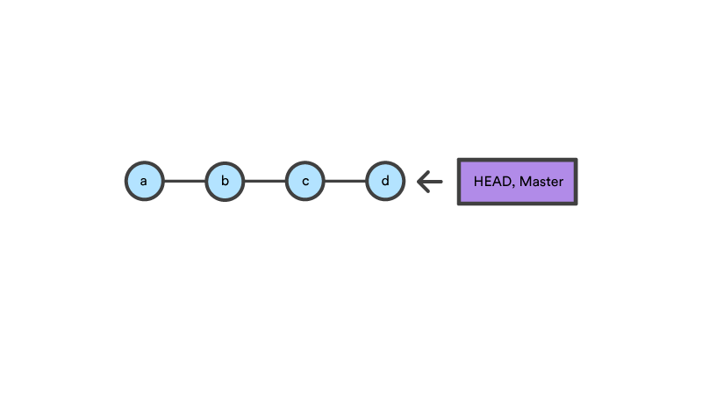
This example demonstrates a sequence of commits on the masterbranch. The HEAD ref and master branch ref currently point to commit d. Now let us execute and compare, both git checkout b and git reset b.

git checkout b
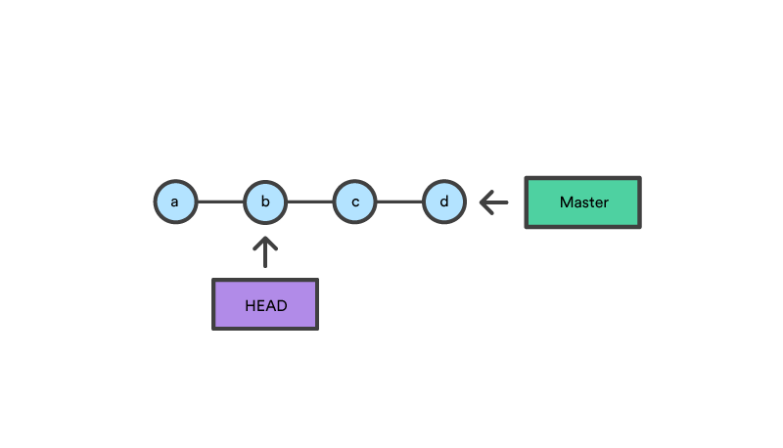
With git checkout, the master ref is still pointing to d. The HEAD ref has been moved, and now points at commit b. The repo is now in a 'detached HEAD' state.

git reset b
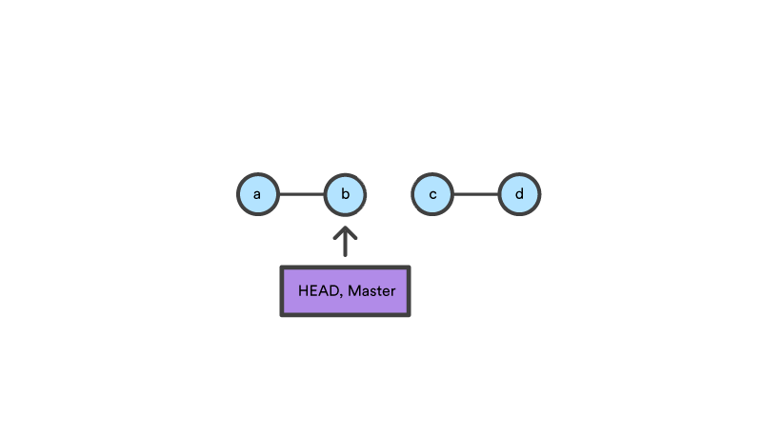
Comparatively, git reset, moves both the HEAD and branch refs to the specified commit.
In addition to updating the commit ref pointers, git reset will modify the state of the three trees. The ref pointer modification always happens and is an update to the third tree, the Commit tree. The command line arguments --soft, --mixed, and --hard direct how to modify the Staging Index, and Working Directory trees.

Main Options
The default invocation of git reset has implicit arguments of --mixed and HEAD. This means executing git reset is equivalent to executing git reset --mixed HEAD. In this form HEAD is the specified commit. Instead of HEAD any Git SHA-1 commit hash can be used.

--hard
This is the most direct, DANGEROUS, and frequently used option. When passed --hard The Commit History ref pointers are updated to the specified commit. Then, the Staging Index and Working Directory are reset to match that of the specified commit. Any previously pending changes to the Staging Index and the Working Directory gets reset to match the state of the Commit Tree. This means any pending work that was hanging out in the Staging Index and Working Directory will be lost.
To demonstrate this, let's continue with the three tree example repo we established earlier. First let's make some modifications to the repo. Execute the following commands in the example repo:
$ echo 'new file content' > new_file
$ git add new_file
$ echo 'changed content' >> reset_lifecycle_file
These commands have created a new file named new_file and added it to the repo. Additionally, the content of reset_lifecycle_filewill be modified. With these changes in place let us now examine the state of the repo using git status.
$ git status
On branch master
Changes to be committed:
(use "git reset HEAD ..." to unstage)
new file: new_file
Changes not staged for commit:
(use "git add ..." to update what will be committed)
(use "git checkout -- ..." to discard changes in working directory)
modified: reset_lifecycle_file
We can see that there are now pending changes to the repo. The Staging Index tree has a pending change for the addition of new_fileand the Working Directory has a pending change for the modifications to reset_lifecycle_file.
Before moving forward let us also examine the state of the Staging Index:
$ git ls-files -s
100644 8e66654a5477b1bf4765946147c49509a431f963 0 new_file
100644 d7d77c1b04b5edd5acfc85de0b592449e5303770 0 reset_lifecycle_file
We can see that new_file has been added to the index. We have made updates to reset_lifecycle_file but the Staging Index SHA (d7d77c1b04b5edd5acfc85de0b592449e5303770) remains the same. This is expected behavior because have not used git add to promote these changes to the Staging Index. These changes exist in the Working Directory.
Let us now execute a git reset --hard and examine the new state of the repository.
$ git reset --hard
HEAD is now at dc67808 update content of reset_lifecycle_file
$ git status
On branch master
nothing to commit, working tree clean
$ git ls-files -s
100644 d7d77c1b04b5edd5acfc85de0b592449e5303770 0 reset_lifecycle_file
Here we have executed a "hard reset" using the --hard option. Git displays output indicating that HEAD is pointing to the latest commit dc67808. Next, we check the state of the repo with git status. Git indicates there are no pending changes. We also examine the state of the Staging Index and see that it has been reset to a point before new_file was added. Our modifications to reset_lifecycle_file and the addition of new_file have been destroyed. This data loss cannot be undone, this is critical to take note of.

--mixed
This is the default operating mode. The ref pointers are updated. The Staging Index is reset to the state of the specified commit. Any changes that have been undone from the Staging Index are moved to the Working Directory. Let us continue.
$ echo 'new file content' > new_file
$ git add new_file
$ echo 'append content' >> reset_lifecycle_file
$ git add reset_lifecycle_file
$ git status
On branch master
Changes to be committed:
(use "git reset HEAD ..." to unstage)
new file: new_file
modified: reset_lifecycle_file
$ git ls-files -s
100644 8e66654a5477b1bf4765946147c49509a431f963 0 new_file
100644 7ab362db063f9e9426901092c00a3394b4bec53d 0 reset_lifecycle_file
In the example above we have made some modifications to the repository. Again, we have added a new_file and modified the contents of reset_lifecycle_file. These changes are then applied to the Staging Index with git add. With the repo in this state, we will now execute the reset.
$ git reset --mixed
$ git status
On branch master
Changes not staged for commit:
(use "git add ..." to update what will be committed)
(use "git checkout -- ..." to discard changes in working directory)
modified: reset_lifecycle_file
Untracked files:
(use "git add ..." to include in what will be committed)
new_file
no changes added to commit (use "git add" and/or "git commit -a")
$ git ls-files -s
100644 d7d77c1b04b5edd5acfc85de0b592449e5303770 0 reset_lifecycle_file
Here we have executed a "mixed reset". To reiterate, --mixed is the default mode and the same effect as executing git reset. Examining the output from git status and git ls-files, shows that the Staging Index has been reset to a state where reset_lifecycle_file is the only file in the index. The object SHA for reset_lifecycle_file has been reset to the previous version.
The important things to take note of here is that git status shows us that there are modifications to reset_lifecycle_file and there is an untracked file: new_file. This is the explicit --mixed behavior. The Staging Index has been reset and the pending changes have been moved into the Working Directory. Compare this to the --hard reset case where the Staging Index was reset and the Working Directory was reset as well, losing these updates.

--soft
When the --soft argument is passed, the ref pointers are updated and the reset stops there. The Staging Index and the Working Directory are left untouched. This behavior can be hard to clearly demonstrate. Let's continue with our demo repo and prepare it for a soft reset.

$ git add reset_lifecycle_file

$ git ls-files -s

100644 67cc52710639e5da6b515416fd779d0741e3762e 0 reset_lifecycle_file

$ git status

On branch master

Changes to be committed:

(use "git reset HEAD ..." to unstage)

modified: reset_lifecycle_file

Untracked files:

(use "git add ..." to include in what will be committed)

new_file

Here we have again used git add to promote the modified reset_lifecycle_file into the Staging Index. We confirm that the index has been updated with the git ls-files output. The output from git status now displays the "Changes to be committed" in green. The new_file from our previous examples is floating around in the Working Directory as an untracked file. Lets quickly execute rm new_file to delete the file as we will not need it for the upcoming examples.
With the repository in this state we now execute a soft reset.
$ git reset --soft
$ git status
On branch master
Changes to be committed:
(use "git reset HEAD ..." to unstage)
modified: reset_lifecycle_file
$ git ls-files -s
100644 67cc52710639e5da6b515416fd779d0741e3762e 0 reset_lifecycle_file
We have executed a 'soft reset'. Examining the repo state with git status and git ls-files shows that nothing has changed. This is expected behavior. A soft reset will only reset the Commit History. By default, git reset is invoked with HEAD as the target commit. Since our Commit History was already sitting on HEAD and we implicitly reset to HEAD nothing really happened.
To better understand and utilize --soft we need a target commit that is not HEAD. We have reset_lifecycle_file waiting in the Staging Index. Let's create a new commit.
$ git commit -m"prepend content to reset_lifecycle_file"
At this point, our repo should have three commits. We will be going back in time to the first commit. To do this we will need the first commit's ID. This can be found by viewing output from git log.
$ git log
commit 62e793f6941c7e0d4ad9a1345a175fe8f45cb9df
Author: bitbucket
Date: Fri Dec 1 15:03:07 2017 -0800
prepend content to reset_lifecycle_file
commit dc67808a6da9f0dec51ed16d3d8823f28e1a72a
Author: bitbucket
Date: Fri Dec 1 10:21:57 2017 -0800
update content of reset_lifecycle_file
commit 780411da3b47117270c0e3a8d5dcfd11d28d04a4
Author: bitbucket
Date: Thu Nov 30 16:50:39 2017 -0800
initial commit
Keep in mind that Commit History ID's will be unique to each system. This means the commit ID's in this example will be different from what you see on your personal machine. The commit ID we are interested in for this example is 780411da3b47117270c0e3a8d5dcfd11d28d04a4. This is the ID that corresponds to the "initial commit". Once we have located this ID we will use it as the target for our soft reset.
Before we travel back in time lets first check the current state of the repo.
$ git status && git ls-files -s
On branch master
nothing to commit, working tree clean
100644 67cc52710639e5da6b515416fd779d0741e3762e 0 reset_lifecycle_file
Here we execute a combo command of git status and git ls-files -s this shows us there are pending changes to the repo and reset_lifecycle_file in the Staging Index is at a version of 67cc52710639e5da6b515416fd779d0741e3762e. With this in mind lets execute a soft reset back to our first commit.
$git reset --soft 780411da3b47117270c0e3a8d5dcfd11d28d04a4
$ git status && git ls-files -s
On branch master
Changes to be committed:
(use "git reset HEAD ..." to unstage)
modified: reset_lifecycle_file
100644 67cc52710639e5da6b515416fd779d0741e3762e 0 reset_lifecycle_file
The code above executes a "soft reset" and also invokes the git status and git ls-files combo command, which outputs the state of the repository. We can examine the repo state output and note some interesting observations. First, git status indicates there are modifications to reset_lifecycle_file and highlights them indicating they are changes staged for the next commit. Second, the git ls-files input indicates that the Staging Index has not changed and retains the SHA 67cc52710639e5da6b515416fd779d0741e3762e we had earlier.
To further clarify what has happened in this reset let us examine the git log:
$ git log
commit 780411da3b47117270c0e3a8d5dcfd11d28d04a4
Author: bitbucket
Date: Thu Nov 30 16:50:39 2017 -0800
initial commit
The log output now shows that there is a single commit in the Commit History. This helps to clearly illustrate what --soft has done. As with all git reset invocations, the first action reset takes is to reset the commit tree. Our previous examples with --hard and --mixed have both been against the HEAD and have not moved the Commit Tree back in time. During a soft reset, this is all that happens.
This may then be confusing as to why git status indicates there are modified files. --soft does not touch the Staging Index, so the updates to our Staging Index followed us back in time through the commit history. This can be confirmed by the output of git ls-files -s showing that the SHA for reset_lifecycle_file is unchanged. As a reminder, git status does not show the state of 'the three trees', it essentially shows a diff between them. In this case, it is displaying that the Staging Index is ahead of the changes in the Commit History as if we have already staged them.

Resetting vs Reverting
If git revert is a “safe” way to undo changes, you can think of git reset as the dangerous method. There is a real risk of losing work with git reset. Git reset will never delete a commit, however, commits can become 'orphaned' which means there is no direct path from a ref to access them. These orphaned commits can usually be found and restored using git reflog. Git will permanently delete any orphaned commits after it runs the internal garbage collector. By default, Git is configured to run the garbage collector every 30 days. Commit History is one of the 'three git trees' the other two, Staging Index and Working Directory are not as permanent as Commits. Care must be taken when using this tool, as it’s one of the only Git commands that have the potential to lose your work.
Whereas reverting is designed to safely undo a public commit, git reset is designed to undo local changes to the Staging Index and Working Directory. Because of their distinct goals, the two commands are implemented differently: resetting completely removes a changeset, whereas reverting maintains the original changeset and uses a new commit to apply the undo.

Don't Reset Public History
You should never use git reset <commit> when any snapshots after <commit> have been pushed to a public repository. After publishing a commit, you have to assume that other developers are reliant upon it.
Removing a commit that other team members have continued developing poses serious problems for collaboration. When they try to sync up with your repository, it will look like a chunk of the project history abruptly disappeared. The sequence below demonstrates what happens when you try to reset a public commit. The origin/master branch is the central repository’s version of your local master branch.
As soon as you add new commits after the reset, Git will think that your local history has diverged from origin/master, and the merge commit required to synchronize your repositories is likely to confuse and frustrate your team.
The point is, make sure that you’re using git reset <commit> on a local experiment that went wrong—not on published changes. If you need to fix a public commit, the git revert command was designed specifically for this purpose.

Examples
git reset <file>
Remove the specified file from the staging area, but leave the working directory unchanged. This unstages a file without overwriting any changes.
git reset
Reset the staging area to match the most recent commit, but leave the working directory unchanged. This unstages all files without overwriting any changes, giving you the opportunity to re-build the staged snapshot from scratch.
git reset --hard
Reset the staging area and the working directory to match the most recent commit. In addition to unstaging changes, the --hard flag tells Git to overwrite all changes in the working directory, too. Put another way: this obliterates all uncommitted changes, so make sure you really want to throw away your local developments before using it.
git reset <commit>
Move the current branch tip backward to commit, reset the staging area to match, but leave the working directory alone. All changes made since <commit> will reside in the working directory, which lets you re-commit the project history using cleaner, more atomic snapshots.
git reset --hard <commit>
Move the current branch tip backward to <commit> and reset both the staging area and the working directory to match. This obliterates not only the uncommitted changes, but all commits after, as well.

Unstaging a file
The git reset command is frequently encountered while preparing the staged snapshot. The next example assumes you have two files called hello.py and main.py that you’ve already added to the repository.
# Edit both hello.py and main.py
# Stage everything in the current directory
git add .
# Realize that the changes in hello.py and main.py
# should be committed in different snapshots
# Unstage main.py
git reset main.py
# Commit only hello.py
git commit -m "Make some changes to hello.py"
# Commit main.py in a separate snapshot
git add main.py
git commit -m "Edit main.py"
As you can see, git reset helps you keep your commits highly-focused by letting you unstage changes that aren’t related to the next commit.

Removing Local Commits
The next example shows a more advanced use case. It demonstrates what happens when you’ve been working on a new experiment for a while, but decide to completely throw it away after committing a few snapshots.
# Create a new file called `foo.py` and add some code to it
# Commit it to the project history
git add foo.py
git commit -m "Start developing a crazy feature"
# Edit `foo.py` again and change some other tracked files, too
# Commit another snapshot
git commit -a -m "Continue my crazy feature"
# Decide to scrap the feature and remove the associated commits
git reset --hard HEAD~2
The git reset HEAD~2 command moves the current branch backward by two commits, effectively removing the two snapshots we just created from the project history. Remember that this kind of reset should only be used on unpublished commits. Never perform the above operation if you’ve already pushed your commits to a shared repository.

Summary
To review, git reset is a powerful command that is used to undo local changes to the state of a Git repo. Git reset operates on "The Three Trees of Git". These trees are the Commit History (HEAD), the Staging Index, and the Working Directory. There are three command line options that correspond to the three trees. The options --soft, --mixed, and --hard can be passed to git reset.
In this article we leveraged several other Git commands to help demonstrate the reset processes. Learn more about those commands on their individual pages at: git status, git log, git add, git checkout, git reflog, and git revert.

